**KEY MILESTONE # 01**

**SPRING 2025**

**Database Management Systems**

Submitted by: **Zarmina Miftah Durrani**

**Noor ul Huda**

**Muhammad Shahbaz Khan**

Registration No. : **22PWCSE2126**

**22PWCSE2205**

**22PWCSE2211**

Class Section: **B**

“On my honor, as student of University of Engineering and Technology, I have neither given nor received unauthorized assistance on this academic work.”

Student Signature:

**Submitted to:**

Engr.Sumayyae Salahuddin

**Submission Date:**

25th May, 2025

Department of Computer Systems Engineering

University of Engineering and Technology, Peshawar

1. **BUSINESS RULES:**

* **User Verification:** Only registered users can place a courier order.
* **Order Uniqueness:** Each courier order must have a unique bill number and ID.
* **Mandatory Details:** Sender and receiver details (names, emails, addresses, phones) are mandatory for all courier orders.
* **Associated User/Admin:** Every courier order must be linked to the user who placed it, and can be linked to an admin for oversight.
* **Login Security:** User and admin login credentials must be valid for system access.
* **Admin Privileges:** Administrators can view, update, and delete any courier or user records.
* **User Deletion Impact:** Deleting a user must also remove their login data and handle their associated courier orders.
* **Contact Logging:** All user contact messages must be recorded and linked to the submitting user.
* **Data Integrity:** All foreign key relationships (e.g., courier to user, login to user) must be maintained for data consistency.

1. **ENTITY DESCRIPTION TABLE:**

|  |  |
| --- | --- |
| **Entity** | **Description** |
| Adminlogin | Stores the authentication credentials for administrators, linking their email and password to an administrator ID. |
| **Admin** | Contains detailed information about each administrator of the system |
| Userlogin | Stores the authentication credentials for general users, linking their email and password to a user ID. |
| Users | Contains detailed personal information for all registered users of the courier service. |
| Courier | Stores comprehensive details for each individual courier shipment, including sender, receiver, item specifics, and associated user/admin IDs. |
| **Comments** | Stores messages or feedback submitted by users, linked to the user who submitted them. |

1. **ER DIAGRAM**

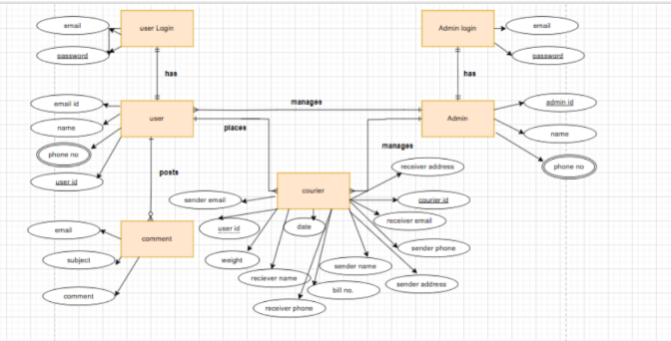

1. **ENHANCED ER DIAGRAM:**

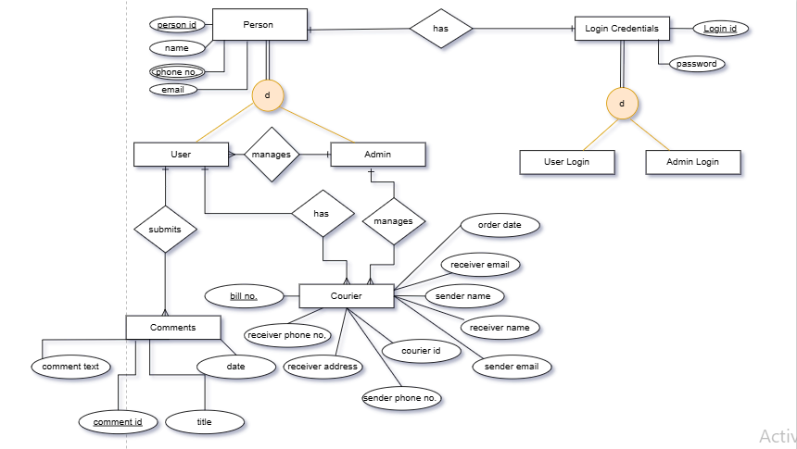

1. **REFERENCES:**

* Chatgpt